ESIC (Employees’ State Insurance Corporation) — New Hire FAQ

1) What is ESIC / ESI?
ESI is a statutory social security and health insurance scheme administered by ESIC for eligible employees in covered establishments. It is funded through employer and employee contributions.

2) Why am I covered under ESIC?
As per the ESI Act, the ESI scheme is applicable to employees whose monthly wages are less than or equal to INR 21,000. As per payroll records your monthly wages are less than or equal to INR 21,000, hence this compliance is applicable for you now.

3) If my salary increases above ₹21,000, does ESIC stop immediately?
Not necessarily. If your wages cross ₹21,000 after the start of a contribution period (after April or October), coverage typically continues until the end of that contribution period.

4) What documents should I share with my current employer for ESIC enrollment?
- Duly filled Excel file (please ensure all fields are completed accurately)
- Duly filled Form 1 in PDF format (please refer to the attached blank and specimen Form 1).
- Photographs: Individual photographs of your nominee and family members are mandatory for completing the registration process. Each photograph must be in JPEG format and between 50 KB and 80 KB in size
- PAN copy: A copy of your PAN is mandatory and must be between 50 KB and 80 KB in size.
- Checklist: Checklist declaration confirming all the above documents are shared with employer.

5) How much is deducted from my salary?
The standard contribution rates are:
Employee/Employer | Percentage of Contribution
Employee | 0.75%
Employer | 3.25%
Total | 4.00%

6) What counts as “wages” for ESIC calculation?
As per the new labor code, wages are defined as basic salary+ Sodexo + Leave Travel Allowance + Special Allowance. ESI is calculated on wages.

7) Who pays ESIC and when is it deposited?
Your employer typically deducts your share from wages, adds the employer share, and remits both to ESIC. The payment is generally due within 15 days after the end of the relevant calendar month.

8) What is Form 1 (ESIC)?
ESIC Form 1 is the employee declaration/registration form used to enroll a new employee under the ESI scheme. Once the employee submits the form 1, enrollment of the employee should be completed within 10 days of hire by the employer on the ESIC portal.

9) How do I know my previous ESIC number, to fill the same in form 1?
Your ESIC Insurance Number/IP number is a unique 10-digit number that stays the same across jobs. The best route is to check your old ESIC card/Pehchan card, past salary records, old employer HR/payroll records, or any prior ESIC login details. If you already had ESIC earlier, you should produce that same number to your new employer, so they link the existing record instead of creating a fresh one.

10) How can I find the nearest dispensary?
Please identify your nearest ESIC dispensary and enter the name and full address in the relevant section of the form. To find the correct dispensary, visit the ESIC website (https://esic.gov.in/) and use the Quick Finder option. Under Quick Finder, select “Dispensary”, choose your State, and click Search as shown in the below image. For faster results, use Ctrl+F and search using your PIN code or you can manually search by scrolling the window. After identifying the nearest dispensary, fill in the dispensary name and address accurately in the form.
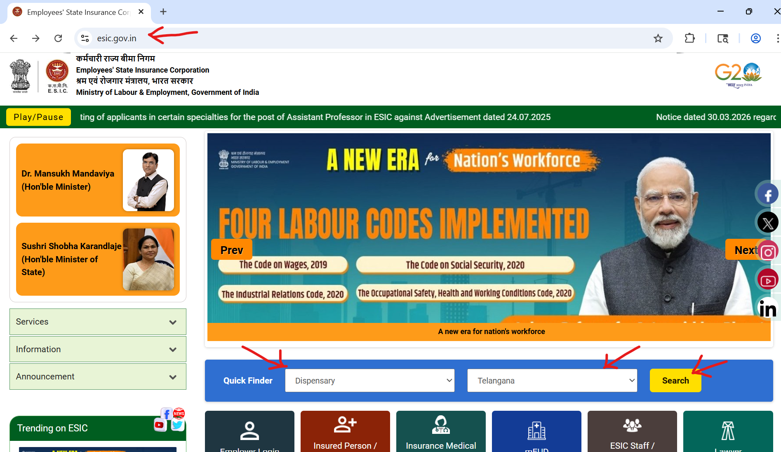

11) What is difference between the ESIC dispensary and ESIC Hospital?
An ESIC dispensary is typically the first point for routine and outpatient care—doctor consultation, basic treatment, medicines, and follow-up. An ESIC hospital handles higher-level care such as specialist treatment, diagnostics, admission, surgeries, and more serious medical needs. Simply put: dispensary = primary access point; hospital = advanced/inpatient care.

12) What is E-Pehechan/ESIC Card?
The E-Pehchan Card (also called ESIC card) is the identity card for an insured employee under ESIC. It proves that you and your registered dependents are covered and helps you access medical and certain cash benefits under the scheme. It contains your IP number, Personal details, dispensary details, employment details, family member details.

13) Where can I get the E-Pehechan/ESIC Card?
You get it after successful ESIC registration is completed through your employer and your IP number is created. In the current digital process, employers generally facilitate the registration and the employee then receives portal/login access; from there, the e-Pehchan card can be issued or printed from the ESIC system.

14) What type of benefits will I get under ESIC Coverage?
ESIC provides both medical and cash benefits. Medical benefits include outpatient care, specialist consultation, diagnostics, medicines, hospitalization, and major treatment for the insured person and eligible family members. Cash benefits include sickness benefit, maternity benefit, temporary/permanent disablement benefit, and dependent benefit in case of employment-related death.
Please refer the document ‘ESIC benefits’ for more information.

15) How do I avail benefits using E-Pehechan/ESIC Card?
Use the E-Pehchan/ESIC card or your IP number as proof of coverage when visiting an ESIC dispensary or hospital. For treatment, the card helps you access consultations, medicines, diagnostics, and hospitalization within the ESIC network; for cash benefits, it supports identification within the ESIC claim process. The key practical point is that your details, dependents, and dispensary mapping should be correctly updated in the system before you need the benefit.

16) How do I raise grievance for ESIC queries?
You can raise ESIC grievance through multiple channels: the ESIC grievance redressal option, CPGRAMS, email to ESIC grievance contacts, toll-free helplines, or by visiting/submitting a complaint at branch, regional, hospital, or other ESIC offices.

